**EXPANDING THE TRAVEL AGENCY TO TRAVEL SERVICES**

**Car Rentals**

* Car rental companies will own cars that are available for renting.
* Cars will have attributes like Car Model, Car Availability, Car Seats, Car Booking Duration.
* The passenger based on his/her requirements can schedule car bookings immediately after the flight booking.
* The passenger will be shown a list of car rental companies of the place where his ticketing destination is set.
* The rental company will ask details about the number of seats, the time duration for rent and the car model and then will display a price for the rent.
* The passenger then will have an option to either book the car rental or decline it.

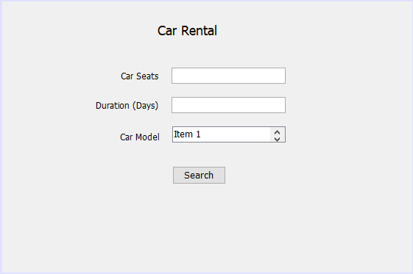

**Hotel Reservations**

* After the car rental is done. The passenger will be redirected to the hotels page.
* Here the customer will be asked to enter details about the number of rooms required and the duration of stay.
* The arrival time on the ticket will be passed as the parameter for check-in date.
* Then the customer will be shown hotel options with prices and images so that the customer can make the final selection.
* Based on the selection a final amount will be generated by multiplying the per day cost into the number of days.

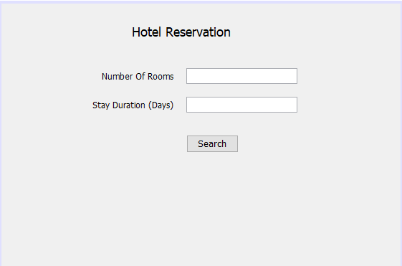

**Support for Multiple Spot Travel Plan**

* The customer will be asked about if he wants to make multiple hotel bookings or not.
* If yes, then he/she will be redirected to a page that will ask the customer to enter check-in dates and check-out dates for the second hotel and the destination location.
* Then based on the dates the available hotels will be shown to the user.
* The user then can make multiple hotel bookings according to the travel plan.

**UML Diagram**

